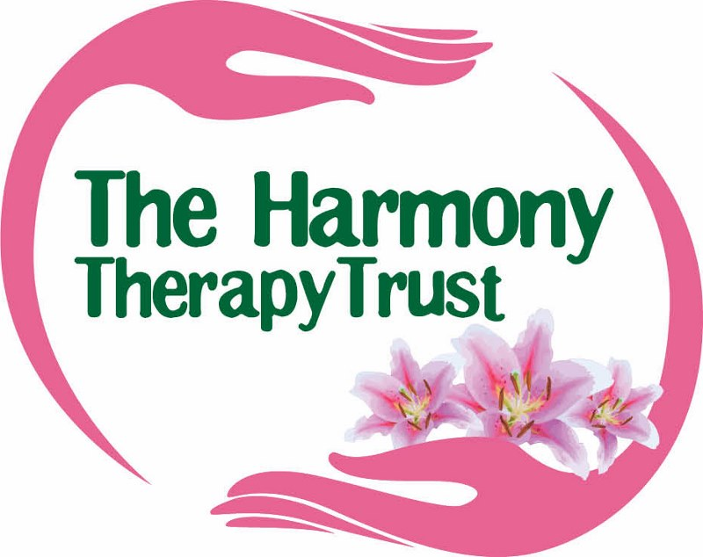
www.theharmonytherapytrust.org.uk

TASTER CLIENT INFORMATION AND DISCLAIMER
Name
Address
Postcode Tel No e-mail

A taster treatment is not the same as a full treatment. However the treatment today should leave you feeling relaxed and refreshed. It is non-invasive and it is not known to interfere with any medication. It is your responsibility however to let us know if you are suffering from any serious illness or recent operation or are in the first trimester of pregnancy as there could be contraindications from having a treatment and you should not have a treatment without first consulting your GP

- Are you on any medication? If so, what is this for and do you know the name and dosage of what it is you have to take?

- Have you suffered/are suffering any serious illnesses?

- Have you have had any recent surgery

- Have you had any kind of holistic therapy before?

- Is it possible you could be pregnant?

Signed Date

NOTES:

WE HOPE YOU ENJOYED YOUR TASTER TREATMENT. PLEASE NOTE THAT IN SOME CASES YOU MAY FEEL SLIGHTLY TIRED AFTER THE TREATMENT AND THE FEELING MAY CONTINUE INTO THE NEXT DAY. IF THIS IS THE CASE PLEASE LISTEN TO YOUR BODY AND REST.

MAKE SURE YOU DRINK PLENTY OF FLUIDS SUCH AS WATER, TEA, FRUIT TEAS, SQUASH, AND FRUIT JUICES AS WELL AS THE OCASSIONAL COFFEE IF YOU PREFER TO ENSURE THAT YOU KEEP WELL HYDRATED. PLEASE ENSURE THAT YOU RELAX FOR THE REST OF THE DAY.

