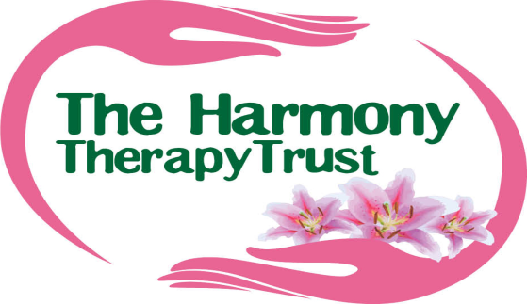

ALCOHOL, DRUGS & SUBSTANCE ABUSE POLICY
INTRODUCTION & SCOPE:
This policy applies to all, Trustees, Therapists and Volunteers, as well as including permanent and temporary employees, agency workers, consultants, self-employed workers and those of work experience.
The Trust is committed to ensuring that it provides and maintains a healthy and safe working environment for all involved with the Trust and for Client/Patients.
The Policy is designed to:
- Help protect from the dangers of alcohol, illegal drugs and other substance misuse.
- Encourage those with an alcohol, drugs or substance abuse problem to seek help to address the problem.
- Fully explain the serious disciplinary consequences for Trust people of not complying with the rules relating to alcohol, drugs and substance abuse.
Policy Aims:
It is the intention to establish an environment in which all feel free to raise problems relating to substance abuse. It is in the interests of both the individual and the Trust to recognise any issue relating to alcohol, illegal drugs, and substance abuse as early as possible and to deal with the problem professionally and confidentially.
The Trust will support any member of the Trust in whatever role who seeks to overcome difficulties relating to alcoholism, drugs and other substance abuse.
The policy also aims to ensure that any member of the Trust is aware of:
- The Trust’s rules concerning alcohol, the possession and use of illegal drugs, and substance abuse.
- When the rules apply, i.e. whenever acting on behalf of the Trust in any capacity at any time.
- Possible disciplinary sanctions as a consequence of non-compliance.

In the chair………………………………………… Date:…………………………………

Prepared by Rita Couzins
Review Date: March 2015.

