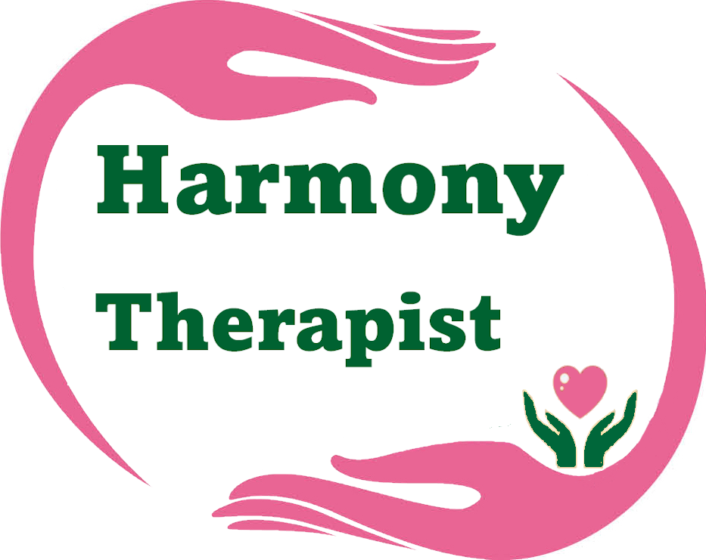

HARMONY THERAPISTS MEMBERSHIP

All therapists receiving referrals and providing sessional support to beneficiaries of The Harmony Therapy Trust (The Harmony Wellbeing Trust) are required to become a member of the Trust.

Benefits of membership
- The right to vote on issues affecting the Trust.
- Add credibility to your own business.
- Promotion of your own business via the Trusts social media pages and website.
- Training and Networking opportunities.
- A newsletter four times a year.
- You will also help ensure that The Harmony Therapy Trust (The Harmony Wellbeing Trust) is here for you — and everyone — long into the future.
Your Responsibilities as a Member:
- Attendance to the Annual General Meeting.
- Provide copies of your professional qualifications and insurance to the Office Manager.
- Support fundraising where possible.

Membership fees are as follows:
- Existing members/current therapists on 14 January 2024 - £25 for the first year and £50 each year thereafter.
- New members - £50 per year.

To join the Harmony Therapists, please complete the form overleaf and return to us. An electronic version of the form will be available on our website https://theharmonytherapytrust.org.uk/
HARMONY THERAPISTS MEMBERSHIP APPLICATION
First Name __________________________________________________________________

Surname ___________________________________________________________________

Business name ______________________________________________________________

Business website_____________________________________________________________

Address – including postcode

___________________________________________________________________________

___________________________________________________________________________

Email ______________________________________________________________________

By joining Harmony Therapists, you agree to pay £50 annual membership fee (£25 for the first year for existing members) and for The Harmony Therapy Trust to hold your details on our mailing list for the duration of your membership.
Membership runs from 1 May to 30 April. If joining midyear, the membership is calculated at £4.50 for each month or part month.

Preferred payment method via bank transfer to The Harmony Therapy Trust, account number 41778463, sort code 40-42-04.

If you cease to take referrals and provide sessional support to beneficiaries of the Trust, your membership will be cancelled, and you will be removed from the mailing list. Membership fees are non-refundable.

The Harmony Therapy Trust uses personal data to build financial and volunteer support, to send communications, to administer donations, grants, volunteering and membership, as well as other activities which promote our aims and objectives. We take great care in how we do this and full details of how we process your data are available in our Data Protection GDPR Policy on our website https://theharmonytherapytrust.org.uk/forms

