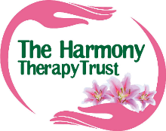
NEWSLETTER 30 SEPTEMBER 2023
It’s been a long time since we produced a newsletter… We’ve been busy making the good news happen so it’s about time we brought you all up to date! It’s been a hectic year and a bit since the last AGM with an active calendar of tabletop sales, boot fairs, markets, craft fairs, village fairs, town carnivals, networking events and supporting other charities events. Whether we’ve been dressed as witches or pirates, wearing QR codes on our backs or pink Harmony hi-vis jackets, we’ve had a load of fun.
10,000 MILES CHALLENGE
In August this year, we reached 10,000 referrals. That’s 10,000 people that we’ve helped since The Harmony Therapy Trust started in 2010. And what better way to celebrate than to spread Harmony to all areas of Kent, while raising money to continue helping those with life limiting/altering conditions to have a little more harmony in their lives through complementary support sessions.
Help us to complete 10,000 miles between August 2023 and August 2024, by doing as many miles as you feel you can, in any way you can, to raise as much as you can (no minimum to sponsorship). Run, walk, jog, swim, dance, cycle, hop, even skydive - there are so many creative ways you can join our challenge.
We have paper sponsor forms that can be posted or collected, or we can email to you. Contact kelly@thtt,org.uk for more information.

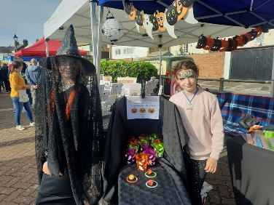 | Here’s just some of the events the team have been up to.  August 2022 – The Island Line Dance Party was well attended and a great night was had by all, raising a fabulous £660.  October, we were at the Queenborough Harbour Halloween Market, where our Mini Harmony Heroes raised £65 with a children’s game and a Trick or Treat Trail. Also in October, we headed down to Dover to Gillians amazing quiz night which raised a total of £650.
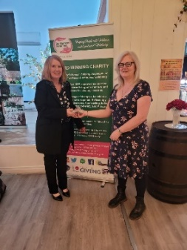 | Enormous well done and thanks to Gillian for a lovely evening in a stunning venue. Oh and... somehow the Harmony Heroes team came 3rd!!  Throughout November and December, we set up stalls at every Christmas Craft Fair and Market we could find, sometimes splitting up and doing two at a time!  In January we held a tabletop sale in the office and in February we attended the World Cancer Day event at Medway Hospital. | 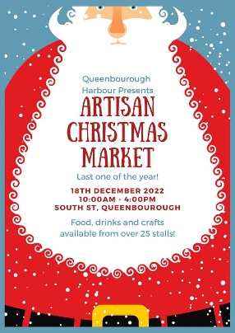
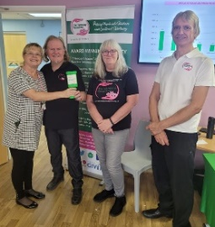 | Around this time, we decided we wanted to attend or host an event in every region of Kent, to raise awareness of The Harmony Therapy Trust. March was the first of our weekly Craft and Conversation groups, also attended by our Mini Heroes and their friends, when on school holidays. This group is going so well, we’re hoping to set up two more in other areas, with funding from Swale CVS. | 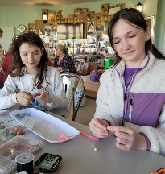
March – we set up a stall at the Rotary Club of Dover’s networking event, where we met lots of lovely people and made many new connections.  April – St George’s Day family fun day in Beachfields Park, Sheerness, followed by an Easter Egg Hunt at Queenborough Harbour Market. |  | 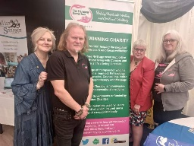
 | 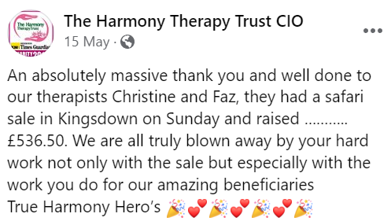 | 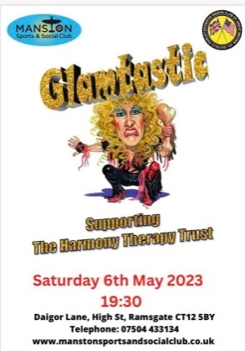
Also, in May we ticked off another regional visit when we went to the Region 17 Bikers event in Manston, with the fabulous Glamtastic. Thanks to the Band, the Bikers and the Manston Sports & Social Club for helping us to raise some more funds.
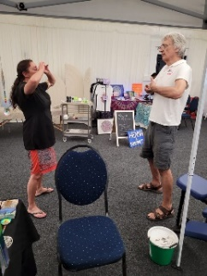 | In June, we booked a pitch at the Kent Wellness Festival at Detling Showground and had a brilliant two days of delivering taster therapies, talking about Harmony, meeting other charities and therapists and a little bit of fundraising. Here’s Rob, Magda and Wendy, getting in the zone and preparing to deliver some taster therapies. | 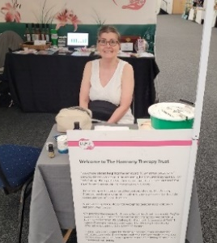
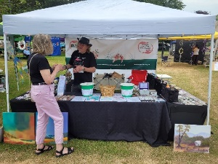 | Also in June, the Dover Multicultural Festival was a lovely event with live music all day and our tombola was very popular.  In July we dressed up in our finery to attend therapist Gillian Pollard’s Rotary Dinner, where she was sworn in as the new President of the Dover Rotary Club. We are both delighted and proud that Gillian has chosen The Harmony Therapy Trust as her Charity of the Year. | 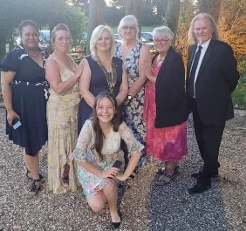
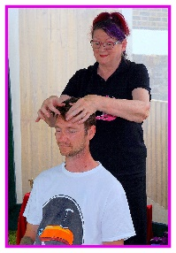  And then, probably the highlight of our year… Harmonyfest… our first music festival. Held in a pub garden, on a lovely sunny day, where all of the acts performed for free. The crowd enjoyed a variety of entertainment from the song signing group, the Island Line Dance Club, an ensemble, a school band, through so many different genres with some ska punk, emo, rock and even a David Bowie tribute. It was a brilliant day and raised £1000.00. Here’s Jill giving a taster Indian Head Massage to one of the festival goers. |  | 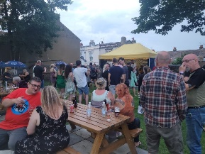
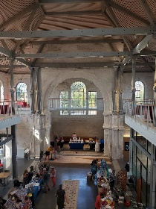  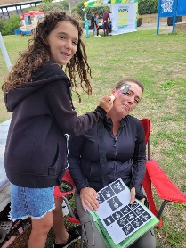  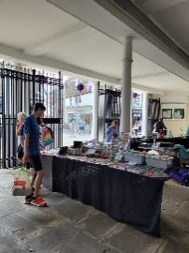  Next, we took over the Deal Undercroft at the Town Hall, with a tabletop sale and ended up going back a couple of weeks later to support the Deal Rotary Pirates fun day, dressed as pirates of course. The Associated Sheppey Bikers put on an event and raised £400 for us.  August started with setting up the gazebo and tables at the Seaside Festival in Sheerness, with three days of events including donkey rides and Punch and Judy shows, ending with the carnival. In September we spent two days at the Faversham Hop Festival, followed by a craft fair in the beautifully restored Dockyard church in Sheerness |  | 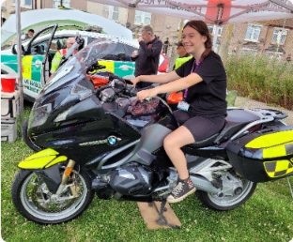
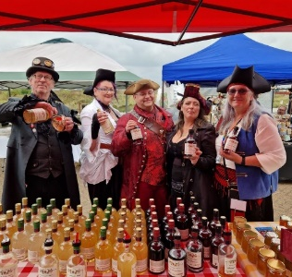 | At our most recent event, we dressed as pirates again to run the Pirate Treasure Hunt at Queenborough Boat Festival and raised over £200.  Coming up in October, we’ve been asked to put on another treasure hunt at the Harbour Market Oktoberfest, and of course, we are booked into lots of Christmas fairs and markets. December 2nd is our fundraiser Line Dance Party, always a good night, and tickets will be on sale soon.  As always, we would love to come and support events near you or help you to plan a fundraiser for us. Just contact lyn@thtt.org.uk or kelly@thtt.org.uk
We are always so grateful to all of our amazing supporters, but have to make special mention of a few who go above and beyond with their generosity and passion for Harmony. Thanks go to Peter Vaughan and his Sound Bath events, raising £432. Also, to Natalie, who literally walked over hot coals for us. Jeff Payne continues to amaze us with donations from his local pubs and is always popping in the office with items to raffle or auction. He even walked 50 miles after a knee operation and raised £525. Jeff, you are a real Harmony Hero – thank you. Thanks also to Simon Horton, of Horton Properties Consultancy Ltd. who has made several kind donations over the year. And last but not least, John Stockham, who takes photos, mostly of bikers and their bikes, and sells prints, donating every penny to The Harmony Therapy Trust. John also collects donations at every opportunity. Just last week he arrived in the office with a bucket full of coins which totalled over £670. Thank you so much, John.  Apologies to anyone I’ve missed out, it’s been a very busy year! |  | 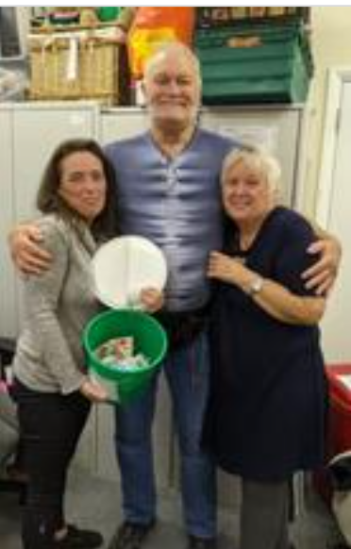  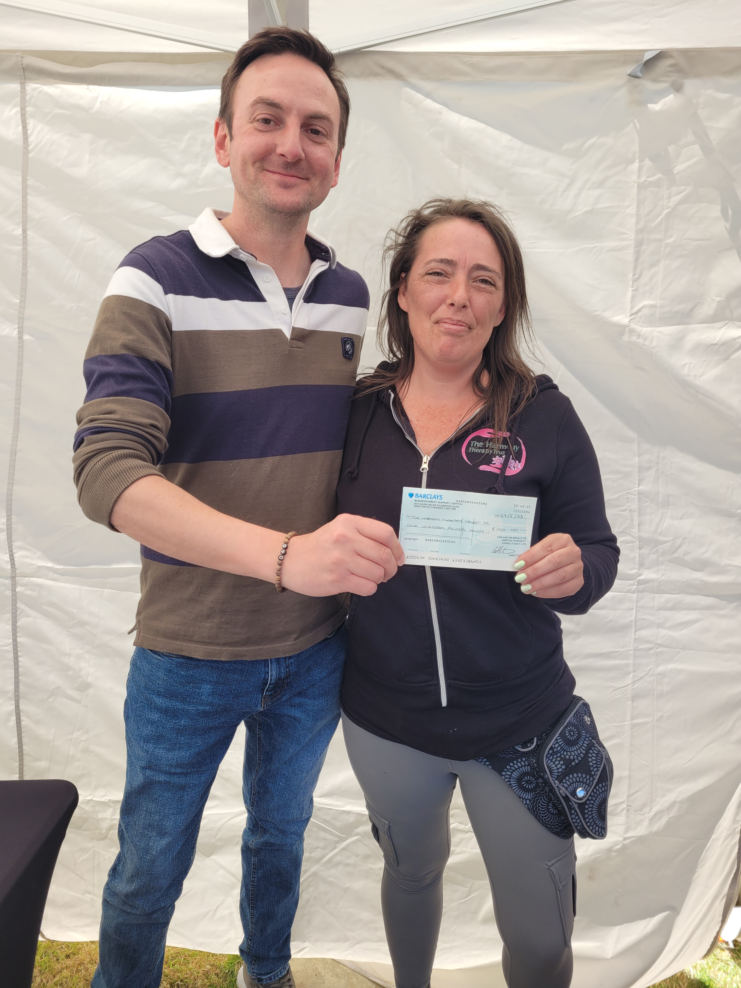

You may be aware that Amazon have ended Amazon Smile, which was a great way to make money for Harmony every time you ordered. However, we are signed up to a couple of similar schemes, which you can join via our website.
Easyfundraising turns your everyday shopping into free donations for your favourite cause. How? Just start your online shopping first at easyfundraising, then shop as normal. Their retailers will then make a small donation to say "thank you."
Give as you Live is a free way to raise money for the Trust, just by shopping online. Once you've signed up, you can browse and select the online store you want to shop with then continue to shop as normal. They will also donate £5 each time someone signs up through the link on our website.

Looking for an alternative to greeting cards? You can support our charity with the cost of cards by sending e-cards instead with Don’tSendMeACard.com
Have you joined our lottery yet? Head over to the website to sign up for just £1 a week.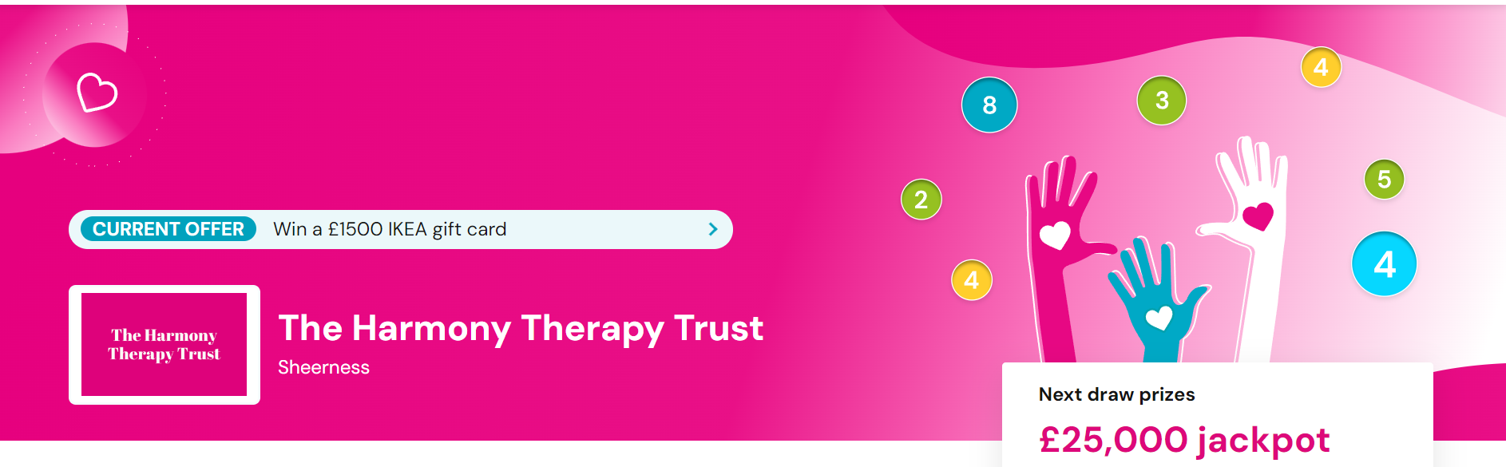

For the admin team, the highlight of the year was the move to the new office, even though there’s been many re-shuffles or the furniture. We’re still in the Healthy Living Centre in Sheerness, but with more space to expand the team, get more desks in and more storage space for all the wonderful items we have donated on a regular basis. We have enough to open a shop, but at this point in time, we don’t have enough volunteers or spare money to set it up. Hopefully, one for the future. Then there was the flood. A leak through the ceiling soaked the back office, destroying donated items and stinking the place out for days! We were lucky enough to be provided with some much needed IT equipment through Computers 4 Charities. Our photo ended up on their publicity leaflets. A lovely surprise to see our team photo on their stall at the Business Vision Live Exhibition at Detling. | The team – Jean, Tony, Tarnia, Kelly, Lyn, Terri  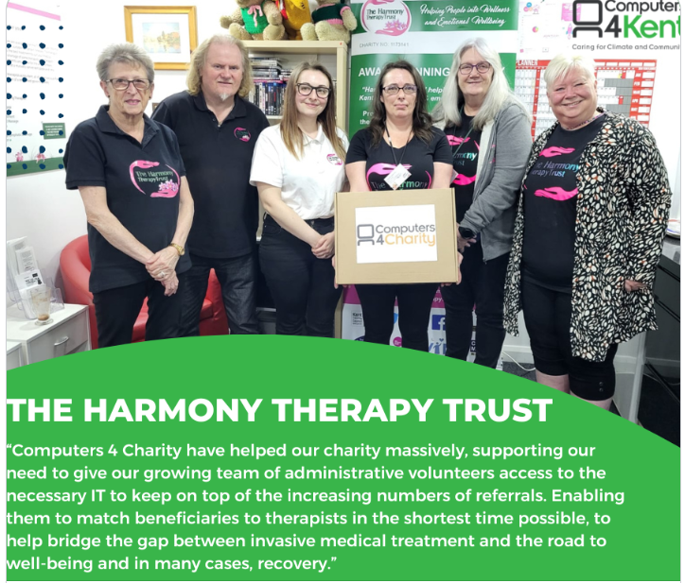

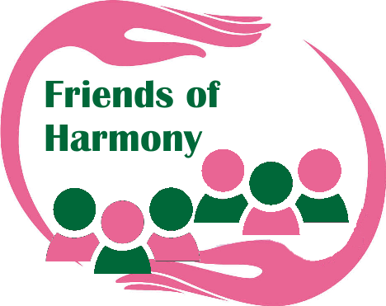 | By becoming a Friend of Harmony, you’ll not only gain members benefits, but crucially, you’ll help ensure that The Harmony Therapy Trust is here for you — and everyone — long into the future.  As a Friend of Harmony, you will qualify for reduced price tickets to our events, free entries to prize draws and raffles, and discounts and special offers from our affiliated artists and crafters. You will also receive a newsletter four times a year with news of events and activities. All this is yours for just £10 a year. Contact lyn@thtt.org.uk for more information.

The admin and events teams have been out there raising awareness of what Harmony do and this has encouraged a higher number of referrals than we’re used to. Like many other charities, the Covid pandemic affected our fundraising activities and the cost-of-living crisis has also meant a reduction in donations and less money spent at events.
BUT… we have a plan to recover and we’re already making great progress.
- New referrals are going on a waiting list, unless for end of life.
- The entire team of Trustees and Volunteers are writing funding bids
- We’re working to increase numbers of Trustees and Volunteers
- We’re reviewing all current systems and activities to improve efficiency
We are confident that these actions, plus new links with other charities and organisations will bring us back to where we want to be, ready for a fresh start in the new year.
The Trustees would like to thank all therapists, volunteers, supporters and friends who work so hard to keep Harmony going as the only charity in Kent that provides free sessional support for people with life-altering illness.

